Build WF User’s Guide

V1.1

By Sam Kanner

Released: Sep 15 2017

Modified: Oct 15 2017

Purpose 1

How to make your first buildWF run: 2

Overview of Code Structure 2

Overview of Input File 4

Flexible Model vs. Rigid Model 7

Calibration of Flexible Model 8

Non-Established Parameters 9

Established Parameters 10

Getting to a Flexible Model 11

APPENDIX A: RAOs 12

Surge 12

Heave 13

Roll 15

Pitch 17

Yaw 19

# Purpose

The purpose of this code is to seamlessly build a WindFloat model in OrcaFlex from a WindFloatX and TurbineX spreadsheet. There are further features to calibrate a Morrison-type model (aka ‘Flexible Model’) with a potential-flow type model (aka ‘Rigid Model’). Even those these models have entirely different formulations and origins (one arising from inviscid theory, the other from empirical studies), they can be tuned and calibrated to exhibit similar platform response.

This document also includes an appendix, which shows some analysis of the rigid model, flexible model and a few models in between.

# How to make your first buildWF run:

1. Get the Code
   1. Get on GitHub
   2. Become a part of PPI-Eng
   3. Download SourceTree
   4. Clone the repos (‘handy_codes2share’ + ‘WindFloatX’) to a folder on your MATLAB path
2. Copy and rename the input file example: Copy ‘Secondary_Codes\buildWF\buildWFipt.sample’ to buildWFipt.m somewhere on your MATLAB path
   1. Change the datfileIN variable to be blank (‘ ’) or another OrcaFlex model to be modified.
   2. Make any other changes to the input file. See Overview of Input File for more information.
3. Open MATLAB
   1. Use the code: buildWF(‘\\path\to\my\inputfile.m’). See Code Structure for more details.
4. Enjoy your new OrcaFlex model which is located as specified by the datfileOUT variable.

# Overview of Code Structure

This section will introduce the functions and sub-functions that are used to build and calibrate WindFloats.

**buildWF**(inputfile)

The main code that is used to build a rigid or flexible WindFloat in version 10.0+ (9.7 to come!). All geometry considerations should be made in WindFloatX or TurbineX spreadsheets and all other specifications can be made in the input file. See Section WindFloat Geometry

All ‘high-level’ WindFloat parameters are defined in the WindFloatX (PlatformX and TurbineX) spreadsheets. The proper amount of information should be entered into this spreadsheet so that the spreadsheet is not too ‘heavy’ but can be used to adequately define a certain design. The spreadsheet should not contain granular information (such as in the weight spreadsheet) that can change quite frequently. Rather, the spreadsheet should contain information, such as beam thickness, turbine section weight, etc that is more stable and changes on the timescale of months. Defining the geometry under version control allows the user to dynamically switch between projects easily. Furthermore, the user is able to work on multiple design iterations of a single project using Git branches. For more information on branches and how to checkout other branches see Git-specific help guides.

If the user would like to make a change to the Platform or Turbine geometry it is required to update the ‘.mat’ file associated with the geometry. In order to do so, use the optional argument to read the Excel spreadsheet and re-write the ‘.mat’ file:

Ptfm = getMyPtfm(‘(insert project name)’,1);

Turbine = getMyTurbine(‘(insert project name)’,1);

Overview of Input File for further details.

**getWFpts**(linenames, various optional arguments)

This function takes a list of linenames (e.g., { 'COL','UMB','LMB','VB','VB'}) and outputs a list of XYZ in global coordinates (with an optional input as the origin) and a cell array of strings corresponding to the WindFloat structure. It can call the subfunction **getMyWEP**, which can read in the KB and WEP coordinates as well.

**Struct = getLineStruct(**various input arguments)

This function sets up the sections of the line to be built in OrcaFlex. It has fields, such as LineType, Length, NumberOfSegments, TargetSegmentLength, which determine the type and length of the sections in OrcaFlex.

**Orient = getLineOrient(**various input arguments)

This function obtains the line ending orientations for a flexible model, which is not trivial. When lines are connected to each other in OFv10+, their end orientations are now defined in a relative manner.

Functions to build objects in OF:

* makeLineTypes (build LineTypes)
* buildOrcaLine (build Lines)
* buildOrca6buoy (build 6D buoys)
* buildAndAttachClump (create Clump Type and attach to Line)

# WindFloat Geometry

# All ‘high-level’ WindFloat parameters are defined in the WindFloatX (PlatformX and TurbineX) spreadsheets. The proper amount of information should be entered into this spreadsheet so that the spreadsheet is not too ‘heavy’ but can be used to adequately define a certain design. The spreadsheet should not contain granular information (such as in the weight spreadsheet) that can change quite frequently. Rather, the spreadsheet should contain information, such as beam thickness, turbine section weight, etc that is more stable and changes on the timescale of months. Defining the geometry under version control allows the user to dynamically switch between projects easily. Furthermore, the user is able to work on multiple design iterations of a single project using Git branches. For more information on branches and how to checkout other branches see Git-specific help guides.

If the user would like to make a change to the Platform or Turbine geometry it is required to update the ‘.mat’ file associated with the geometry. In order to do so, use the optional argument to read the Excel spreadsheet and re-write the ‘.mat’ file:

* Ptfm = getMyPtfm(‘(insert project name)’,**1**);
* Turbine = getMyTurbine(‘(insert project name)’,**1**);

# Overview of Input File

**Main Parameters**

*OFver* [float] = OrcaFlex version. If OFver>=10.0, lines can be connected to each other and the ‘flexible’ model is simplified. *A rigid model in OFver>=10.0 must not use the load RAOs in the VesselType in the same way as OFver<10.*

*iRigid* [logical] = If set to 1, the code builds a ‘rigid’ model, with a vessel (unsupported in v0); if set to 0, a ‘flexible’ model is built, with the type of connections specified by OFver.

**Naming Parameters**

*datfileIN* [string] = Absolute path of input OrcaFlex file. If specified, the model will be loaded and then be modified accordingly. If not specified, the model will be built from a blank slate. Thus, any features, such as a mooring system from previous models would not be loaded in.

*datfileOUT* [string] =Absolute path of output of OrcaFlex file. I*f the file exists, it will be overwritten.*

*PtfmType* [string] = This string refers to the matfile/Excel file that is stored in the WindFloatX repository describing the main characteristics of a platform. The matfile contains a structure which is called by many of the functions and sub-functions.

*TurbineType* [string] = This string refers to the matfile/Excel file that is stored in the WindFloatX repository describing the main characteristics of the turbine. The logical *iTurbine* must be set to 1 for the turbine to be built.

**Other Logicals**

*iAdamantium* [logical] = If set to 1, the axial and bending stiffnesses of the turbine and platform are multiplied by 1000.

*iTurbine* [logical] = If set to 1, the turbine, RNA are built and/or modified; if set to 0, a permanent ballast mass equal to the turbine’s weight will be added to column 1.

*iBlades* [logical] = If set to 1, the blades are built and/or modified with the correct local orientation of the blades in order to set the proper asymmetric drag coefficient.

*iplot* [logical] = If set to 1, 3D plots of the structure and the WEPs will be produced before the OrcaModel is created. This functionality is helpful for debugging a PlatformX spreadsheet.

*iOF* [logical] = If set to 1, the ofx MATLAB/OrcaFlex interface will be called and a valid OrcaFlex license must be available. This must be set to 1 to build a model in OrcaFlex. This value should only be set to 0 for debugging purposes.

**WEP Parameters**

*iWEP* [logical] = If set to 1, the WEPs will be built.

*WEPtype* [string] = Name of the WEP to be built. This naming variable is set in the WindFloatX spreadsheet.

*CdWEP* [float] = Value for Cd of total WEP plate. $F_{vertical}=0.5*ρ*C_{d}*A_{WEP}*u|u|$. The area of the WEP is calculated automatically from the WEP tab in the WindFloat spreadsheet.

*CdDiam* [float] = Drag diameter for Morison (quadratic) drag of WEP plates. Must be specified in order to determine the drag coefficient in OrcaFlex, as: $C_{d,OrcaFlex}=\frac{C_{d,WEP}*A_{WEP}}{{Perimeter}_{WEP}*C_{d,DIAM}} .$

*AddedMassZ* [float] = Total heave added mass of WindFloat, in kg. This value should be set to the long-wave limit of the platform.

*WEPD* [float] = Buoyancy (outer) diameter of the WEP lines, which are built around the perimeter. Total displacement of the WEPs is equivalent to the area of a circle (defined by this diameter) multiplied by the total perimeter of the WEPs.

*nUwep* [integer] = Number of unique WEP types to be built.

*specWEP* [cell array of strings] = A list of strings specify which WEP lines should be treated with extra added-mass weight. Could be left blank, in which case the number of WEP lineTypes will equal **nUwep*.*** The letter specified must be the first letter in the WEP naming scheme. For instance, in order to weight lines ‘AA’ and ‘AB’ (full line names ‘WEP1AA’ and ‘WEP1AB’), set *specWEP* to {‘A’}.

*nX* [float] = The amount of added-mass ‘weight’ given to the **specWEP** lines. The length of this vector must equal the length of the cell array of *specWEP* (unless it is left blank).

**Other Parameters**

*CaCOL* [float] = Actual value for Ca coefficient of all Column LineTypes. For a rigid model this value should be set to 0 since the added mass of the columns is taken into account in the vessel (by WAMIT).

*X1*  [1x3 float] = Location of intersection of SWL and Col 1 in OrcaFlex.

*linenames* [cell array of strings] = Type of lines to be built per side of WindFloat. The most common configuration is {'COL','UMB','LMB','VB','VB'}. The number of lines specified (ie., length of list) is referred to as **nLines.**

*nLevel* [1 x **nLines** integer] = The number of lines to be built for each line on each side of the WindFloat. The length of the vector must equal **nLines** (the length of the cell array of *linenames*). For instance, a common discretization level for the ‘rigid’ model is [1 4 4 3 3], using *linenames* = {'COL','UMB','LMB','VB','VB'}. This specification will build 4 lines for each UMB1, UMB2 and UMB3 as “UMB1a”, “UMB1b”, … “UMB3c”, “UMB3d”.

# Flexible Model vs. Rigid Model

The main differences between a ‘flexible model’ and a ‘rigid model’ are the different models used to compute the hydrodynamics and structural dynamics of the platform. For the purpose of this discussion, the (coupled or decoupled) aerodynamics are ignored. It should be noted that the coupling of FAST and OrcaFlex (aka OrcaFAST) was performed with the ‘rigid model’ in mind.

A ‘rigid model’ uses a classical frequency-domain approach to estimate the hydrodynamic forces on the floating body. Since all hydrodynamic properties in the model are defined in a global sense, there can be no localized forces on different parts of the body. Hence, the floating body is considered rigid and no relative degrees of freedom are given in the model. The global hydrodynamic properties are calculated a-priori by programs such as WAMIT, AQWA or other frequency-domain programs. In OrcaFlex, these global properties are input into a ‘Vessel Type’. Other forces, such as viscous forces, can be defined locally as in the ‘flexible model’. Line members are attached rigidly (on either end) to a Vessel.

Historically, at Principle Power, the truss of the WindFloat platform is not modeled in the frequency domain. Thus, the structural members, such as the main beams and v-braces are modeled using a Morison formulation, while only the columns and WEPs are modeled in the frequency domain. However, there is no theoretical reason for this modelling choice and only serves to simplify the analyses in the frequency-domain software.

A ‘flexible model’, on the other hand, uses a simple Morison equation formulation where the local properties of the members of floating body can be uniquely defined. However, the coefficients of a Morison formulation (i.e., Ca, Cm, Cd) cannot vary with the frequency of the incident wave. There is no vessel in this model. The line members are either connected to each other or to other free degrees of freedom, such as buoys.

An overview of the differences in the models is shown in Table 1.

Table 1. General differences between the flexible and rigid models.

|  |  |  |
| --- | --- | --- |
|  | Rigid Model | Flexible Model |
| Hydrodynamic Loads | Global | Local |
| DOFs | 6 | 6 x nNodes |
| Added-mass | Frequency-dependent | Ca |
| Hydrodynamic damping | Frequency-dependent | None |
| Wave-exciting force | Frequency-dependent | Cm |
| Quadratic damping | Cd | Cd |
| Linear damping | Global | Distributed around the platform |

# Calibration of Flexible Model

The first steps of the hydrodynamic calibration of the flexible model are to perform identification tests, such as free-decay tests, force-excursion curves, and system responses in regular waves in order to determine the global performance. (*See RunOF manual for easy ways to set up these tests in OrcaFlex.)* Generally, a few parameters must be tuned in order to obtain an adequate response, relative to the ‘rigid’ model which is the baseline for comparison. In order to determine the values of these parameters, models are built and subjected to identification tests. Generally, comparing the responses of the models in regular waves (aka ‘RAO’ curves) is the easiest method to determine the fidelity of ‘flexible’ models in the wave regime. Although other identification tests, such as free-decay tests or force-excursion curves are helpful in identifying the behavior of the flexible model, they generally do not recreate behavior seen in the wave-regime. Furthermore, a flexible model should have a different behavior in free-decay tests in roll and pitch motion as the interaction between the flexible tower and hull can lead to a different response than the rigid model. Sometimes decreasing the differences in the free-decay tests (in either resonant frequency or damping) can create larger differences in the ‘RAO’ curves at higher frequencies located in the wave regime.

## Non-Established Parameters

* Ca, Cd of WEPs

The total Cd of the WEP has been set to 3, in order to maximize the motions (and loads), which leads to a more conservative model. The total Ca of the WEPs should be set to the long-wave (zero-frequency) limit added-mass of the ‘rigid’ system. This has been found to give a response most like the ‘rigid’ model around the heave resonance frequency.

* Distributions of added mass about WEP (ie., ‘center of added-mass’)

The pitch/roll response (as well as the tower eigenfrequency) has shown to be sensitive to the distribution of added mass on the WEP. Since this issue is so geometry dependent, there is generally no pertinent literature. In order to move the ‘center of added-mass’ of the WEP, a number of WEP lines are considered to be ‘weighted’ more heavily with added mass than others. In this way, the total added mass of the WEP is unchanged but the ‘center of added-mass’ can be moved. In the input file this effect is parameterized by **nX,** which is a multiplicative factor of the added mass over the even distribution. The added-mass of the non-effected lines are reduced, so that the total added mass of the WEP is unchanged. For now, the total added mass of the 3 WEPs are considered to be equal, even though the ‘top’ area of the WEP (i.e., the area of the WEP minus the column area) is different. Again, the sum of the total added masses of all 3 WEPs should be approach the total added mass of the ‘rigid’ system in the (zero-frequency) long-wave limit.

An example of the effect of **nX** on the pitch response can be seen below in an RAO plot:

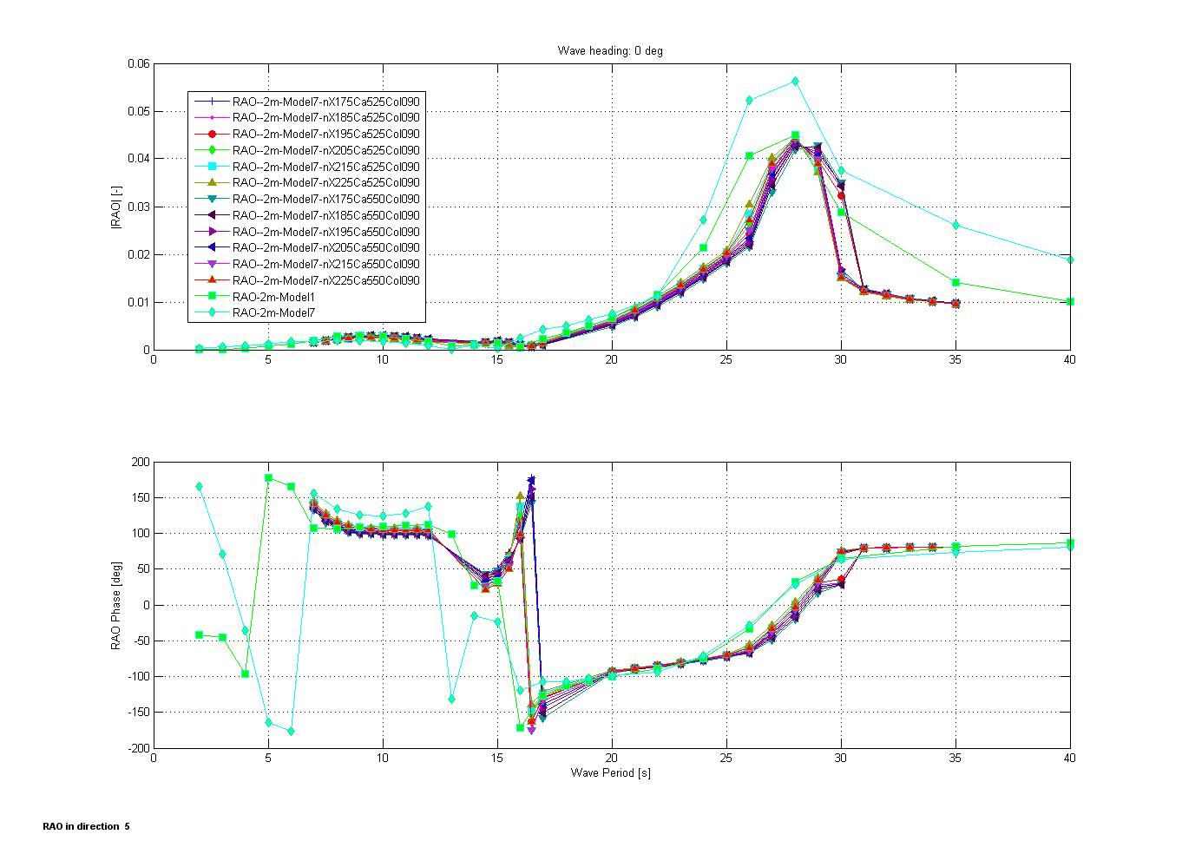

Figure . Roll RAO of ‘flexible’ WindFloat platforms with varying ‘nX’ values. Model 1 is considered the baseline rigid model, while Model 7 is considered the baseline flexible model. Increasing values of ‘nX’ moves the location of the center of added mass of the WEP inboard.

## Established Parameters

Other parameters are taken to be given as they are more well established in the literature in flows with similar Reynolds, KC and surface roughness numbers.

* Ca, Cd of slender members, such as LMB, UMB, VB, Tower (1.0 and 1.2, respectively)
* Ca, Cd of non-slender members, such as columns (0.8 and 0.65, respectively)

Table 2. Sources of Morison coefficients in flexible and rigid models.

|  |  |  |
| --- | --- | --- |
|  | Rigid Model | Flexible Model |
| Ca, Cm of Columns | None (included in added-mass and wave-exciting force) | From literature |
| Cd of Columns | From literature | From literature |
| Ca, Cm of WEP | None (included in added-mass and wave-exciting force) | Tuned to match heave/roll/pitch behavior of rigid model |
| Cd of WEP | From literature | From literature |
| Ca, Cm of Truss | From literature | From literature |
| Cd of Truss | From literature | From literature |

# Getting to a Flexible Model

In order to determine the hydrodynamic effect of moving from a potential flow formulation to a Morison-based formulation a number of models were constructed. They were named as follows:

Table . Summary table of models used to study effect of various hydrodynamic (and hydrostatic) formulations in OrcaFlex.

|  |  |  |
| --- | --- | --- |
| Model Number | Purpose: "To investigate the effect of…" | Explicit Differences in Models |
| 1 | Base Case (Rigid) | N/A |
| 2 | Infinite added mass/damping | • Mu(sigma) and Lam(sigma) replaced by Mu(T=1) and Lam(T=1) |
| 3 | Buoyancy on lines (not WAMIT stiffness) | • Displaced vol =0 • K_vessel = zeros(6,6) • OD_cols=[12.044,15.54,11.54] |
| 4 | Removing constant Mu, Lambda matrix (using Ca on lines instead) | • Removed Disp RAOs, Load RAOs, Drift • Removed Mu, Lam • Changed OD_WEP= 0.305 m  • Changed Ca_Col = 0.9, Ca_WEP= [0,200] |
| 5 | Changing mass to buoy to correct hydro stiffness | • Removed Mass, MOI of Vessel • Added 6D buoy at platform center with M, MOI |
| 5b | Replacing Vessel with 6D Buoy | • Removed Vessel • Transferred LD of Vessel to Buoy |
| 6 | Linear damping on columns (instead of center of vessel) | • Transferred LD of Vessel to column Buoys |
| 7 | Final Case (Fully flexible) | • Vessel is removed (line ends now free) • Mass on lines and point masses • Lines follow primary steel structure (10xE inside OS) |
| 7r | Removing the vessel, but no flexibility in lines | • All lines have E=1000*E_steel (including tower) • Tweaked tol's to get static+dynamic convergence |

Despite larger differences in Models 2-6, good agreement between Models 1 and 7 can be obtained with the proper tuning of Ca’s and Cd’s, especially on the WEPs. RAO curves of each of the models are shown in APPENDIX A: RAOs.

# APPENDIX A: RAOs

The trends in Figure 3-Figure 6 show that despite losing fidelity in the intermediary models, the baseline rigid model (‘Model 1’) and the fully flexible model (‘Model 7’) show good agreement. In the flexible model, excitation in the WindFloat near the pitch/roll resonance occurs, which can be seen in the yaw RAO (see Figure 6).

## Surge







Figure 2. Surge RAOs for Models 1-7. See Table 3 for more details on model definitions.

## Heave



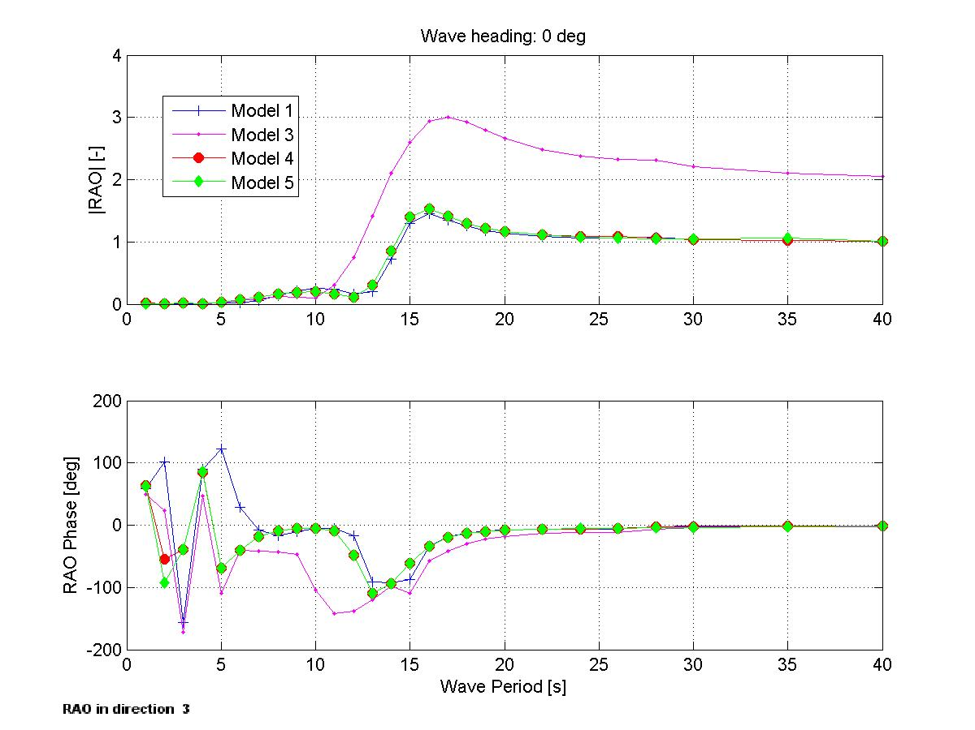

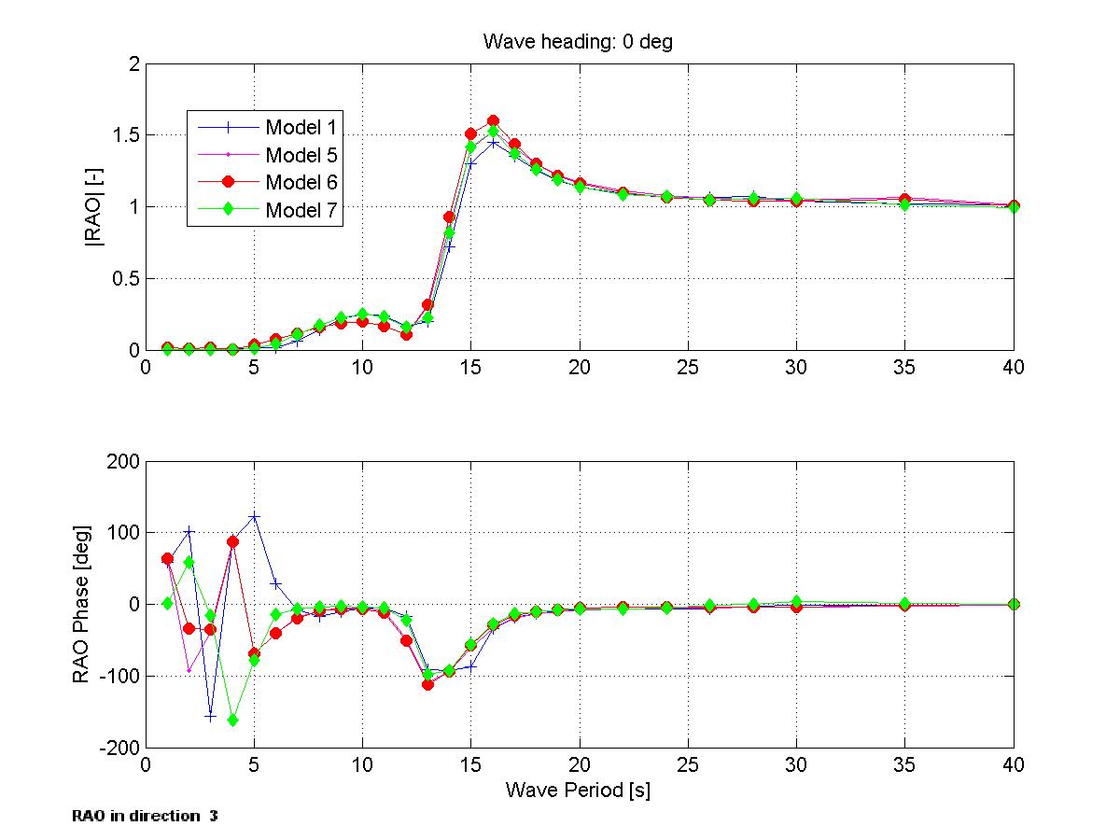

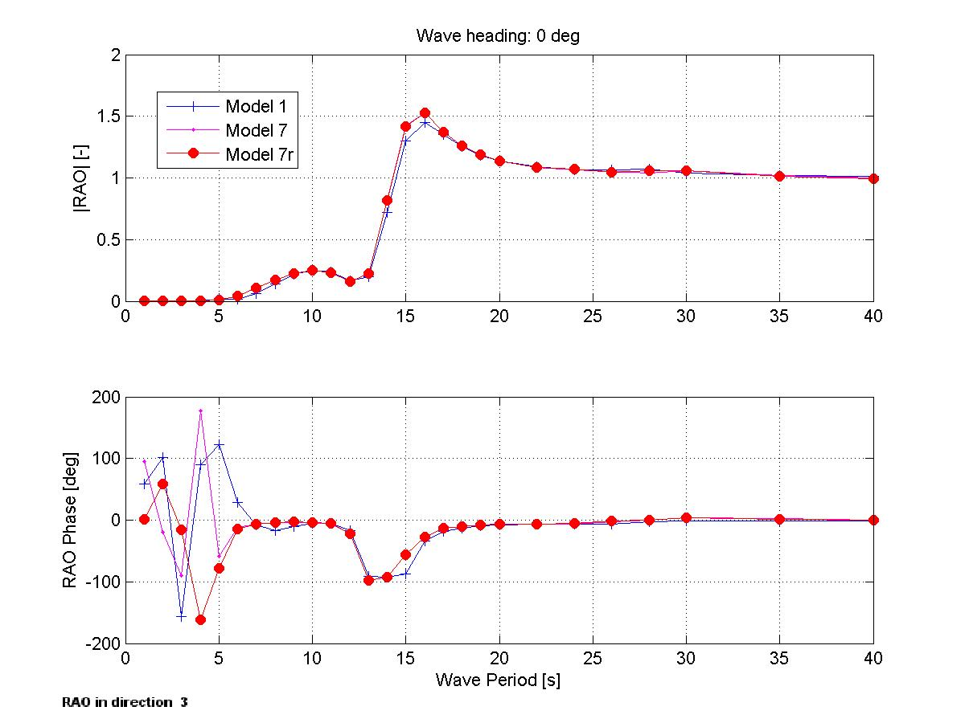

Figure 3. Heave RAOs for Models 1-7. See Table 3 for more details on model definitions.

## Roll

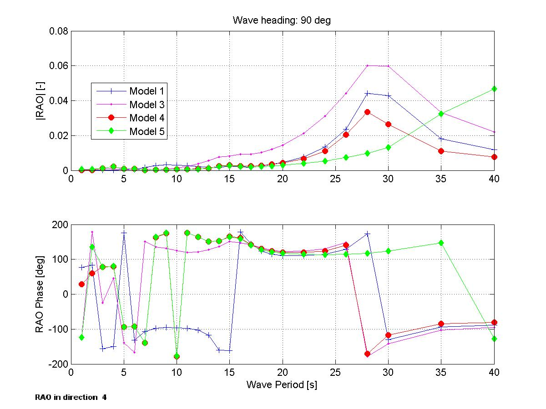

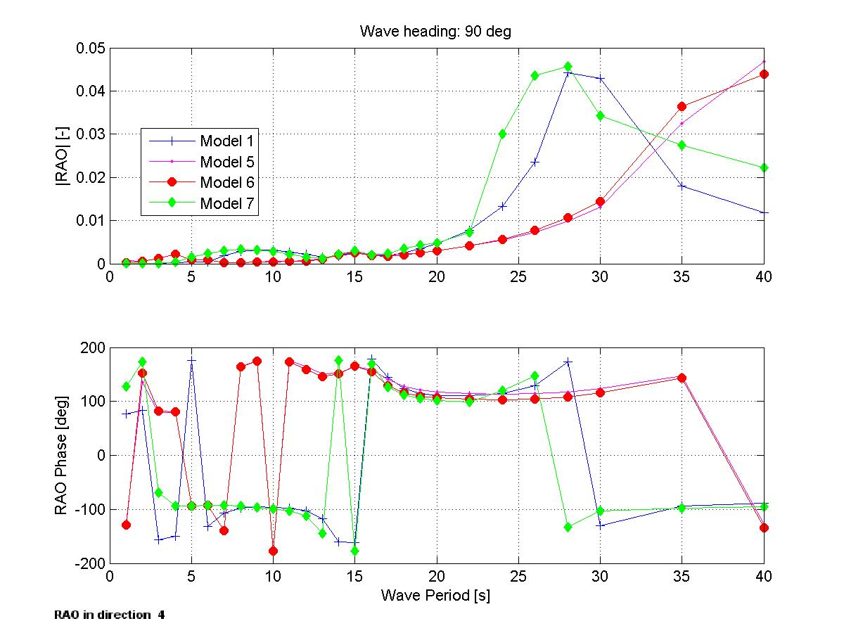

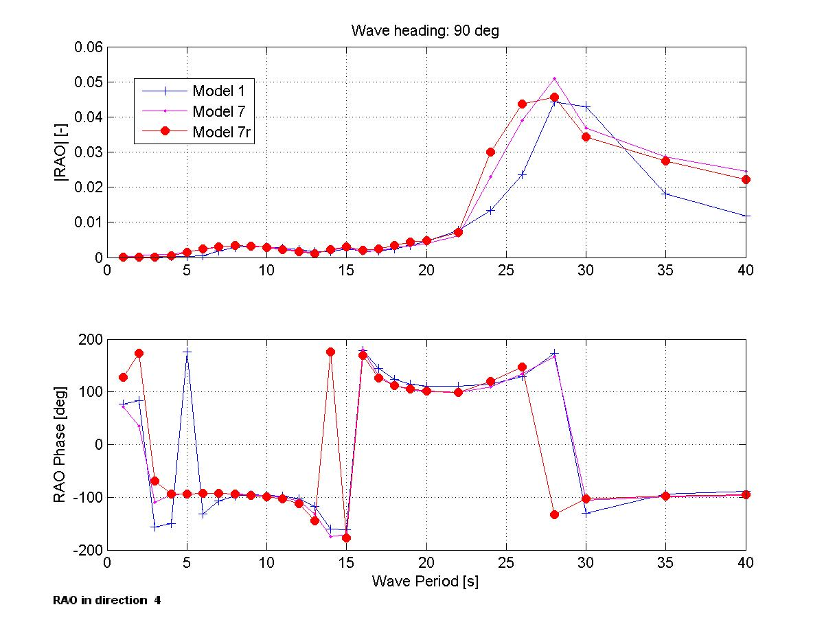

Figure 4. Roll RAOs for Models 1-7. See Table 3 for more details on model definitions.

## Pitch

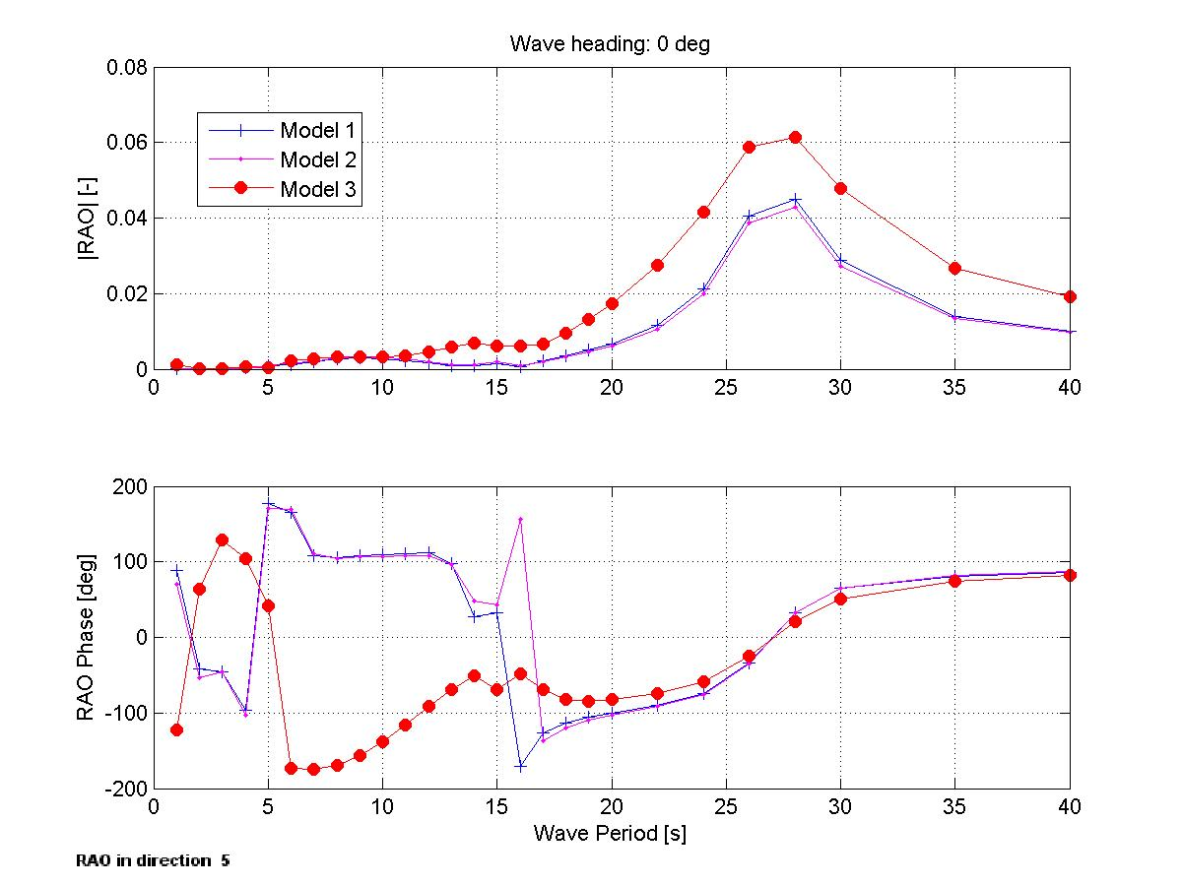

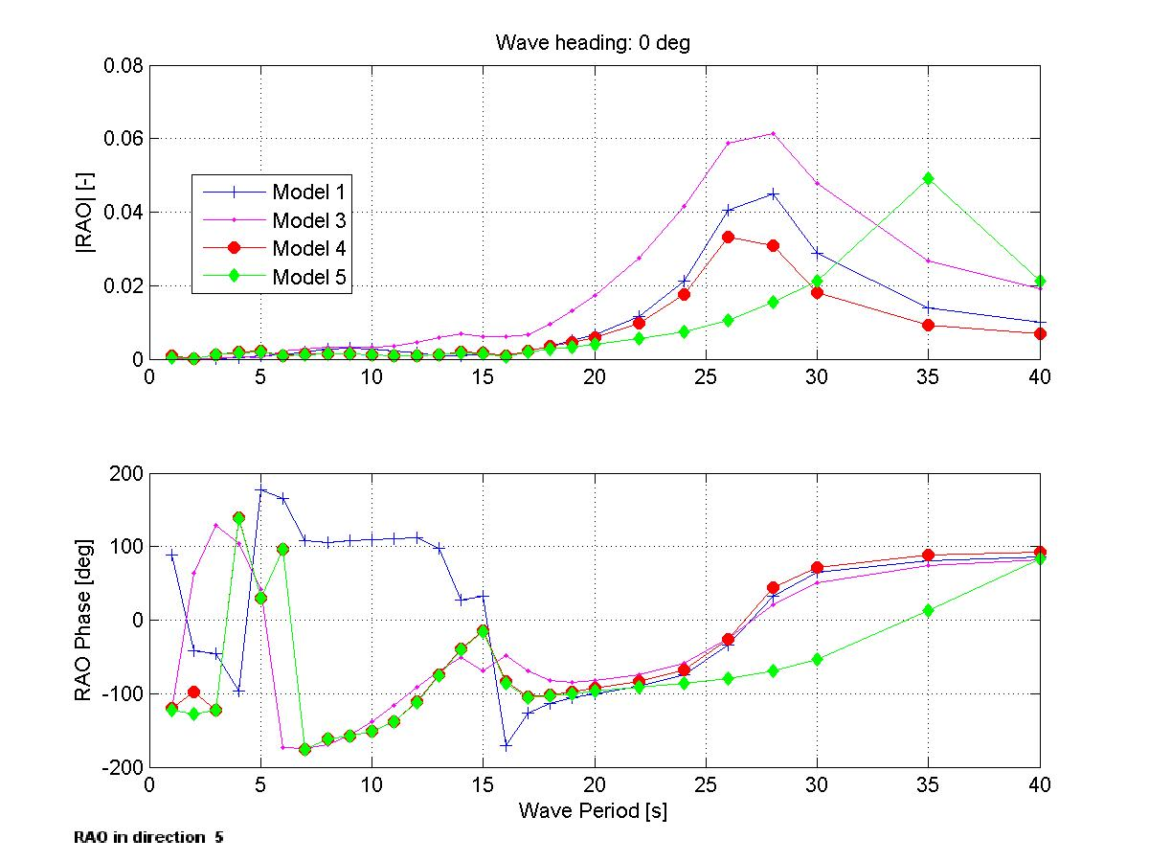

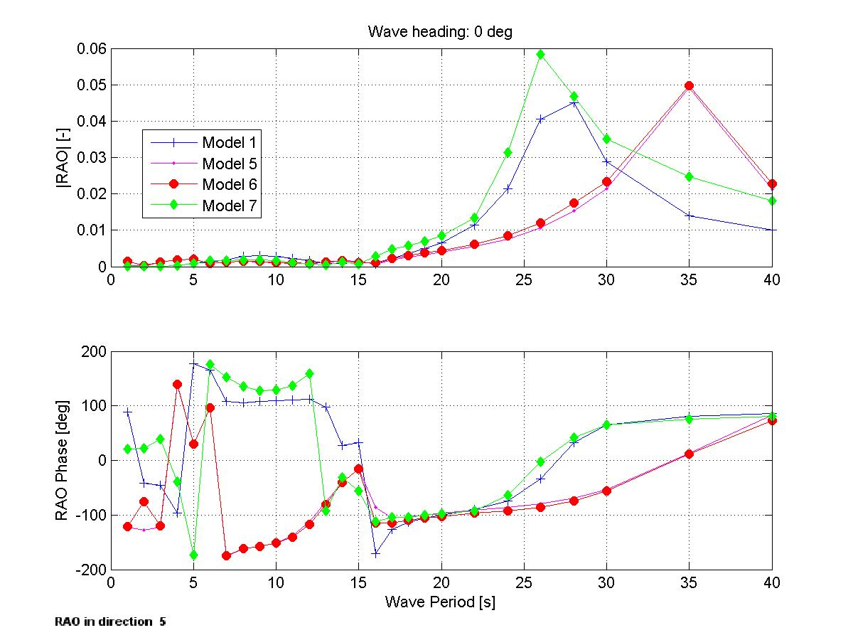

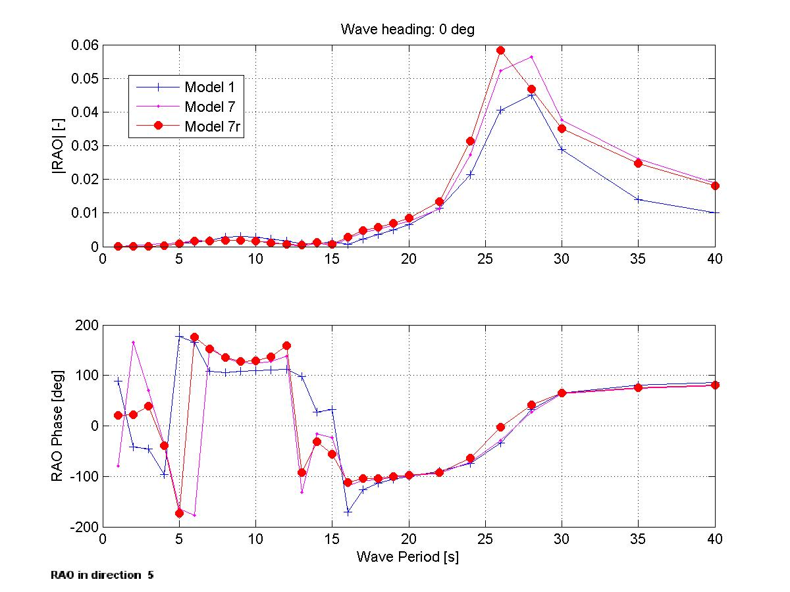

Figure . Pitch RAOs for Models 1-7. See Table 3 for more details on model definitions.

## Yaw



Figure . Yaw RAOs for Models 1 and 5-7. See Table 3 for more details on model definitions.